Interview Questions

Tree Growing Questions

1. General Tracing Questions
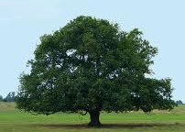

Question | Likely Answers or Notes
How each enabler helps the tree grow  1. What does the tree need in order to grow?  [Elicit a list of enablers: air, water, soil (nutrient), and sunlight. For enablers not mentioned, ask: Other students told me that the tree needs X to grow. Do you agree?] | Level 1. Water moves inside the tree. Then it helps the tree to grow. Sunlight hits the tree’s leaves and keeps the tree warm. Soil keeps moisture for the tree. Air helps the tree breathe. When the tree has alls these things, it grows bigger and bigger. When it is bigger, it has more wood.  Level 2. The tree uses air, sunlight, nutrients in soil, and water to make food. Food helps the tree to grow more wood.  Level 3. Carbon dioxide and water and sunlight become glucose. Glucose is the energy that helps the tree grow.  Level 4. Carbon dioxide and water become glucose and oxygen in photosynthesis. Energy of sunlight becomes chemical energy stored in glucose molecules.
How the tree grows its wood
1. When a tree grows it adds wood to its trunk. What are your ideas about how the tree makes new wood in its trunk?
2. How does the tree use each of the things that it needs (list from student) to make wood in its trunk?
3. Do other parts of the tree help the tree to make wood in its trunk?
- How do the leaves help?
- How do the roots help?
3. Does the tree breathe?  - How does it do that? What gases are involved?  - What parts of the tree are involved in breathing [exchanging gases]?  - Is there a connection between breathing [exchanging gases] and growing for the tree?  - [If student says yes] What is the connection? | Note that leaves exchange CO2 for O2 in sunlight, while leaves and roots exchange O2 for CO2 continually.

Cards for students to discuss: For Matter Association (7 cards),
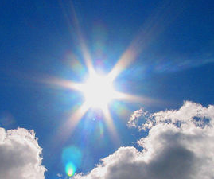 | 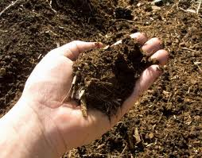 | Oxygen (O₂) | Carbon dioxide (CO₂)
Sunlight | Soil | In Air | In Air
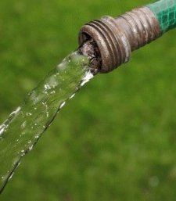 | 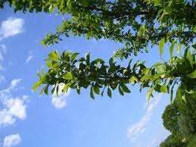 | 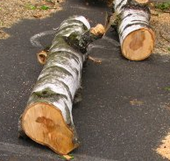 | 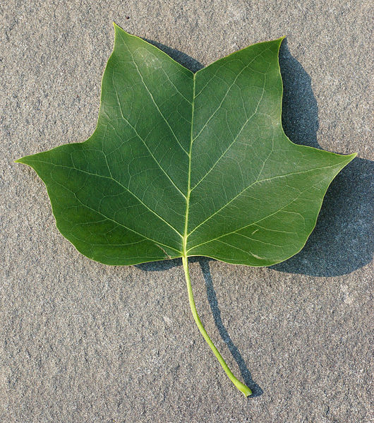
Water | Living Branches | Dead Wood | A Leaf
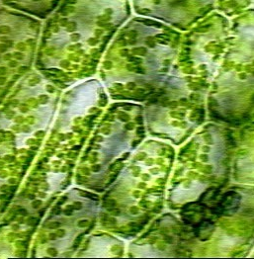 |  | 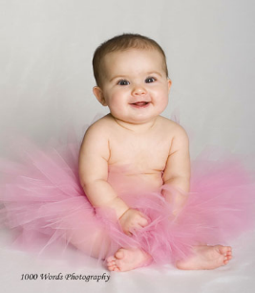 | 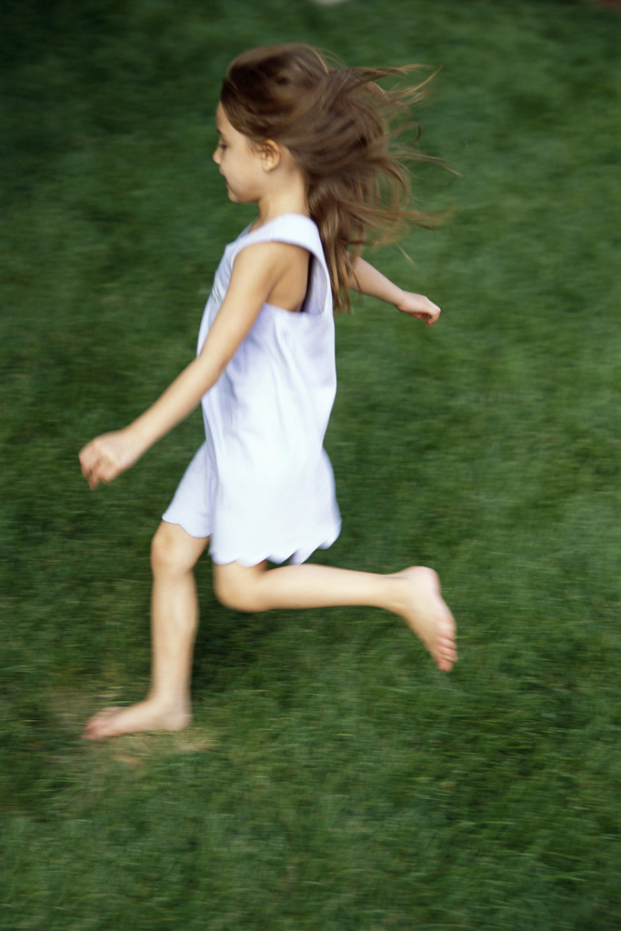
Leaf cells | Tree Growth | Baby girl growth | Girl Running
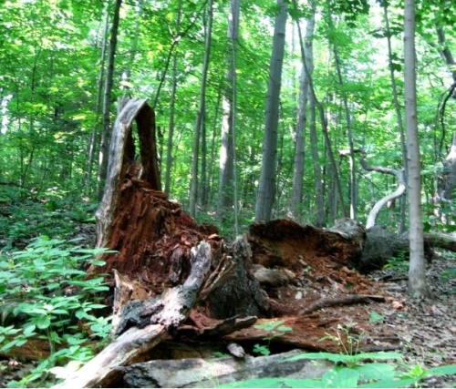 | 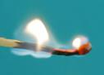 | 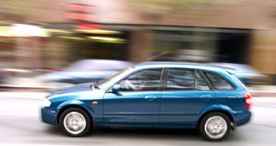
Tree Decaying | Flame burning | Car running
2. Matter Association Questions: How Materials are Alike and Different (Use the first 7 cards—all except the leaf and leaf cell)
Question | Likely Answers or Notes
1. Ask students to sort the first 7 cards: Please sore these cards into two groups. One group has things that are matter. The other group has things that are not matter.
2. Let’s compare the things in the matter group:
- How are these things alike? How are they different?
- Can you change some of these into others (other than living branches becoming dead wood)?
3. Let’s talk about energy:
- Which of these has energy?
- Ask about each thing the student named: You said that X has energy. Why? How do you know that?
- You said that X, Y, and Z all have energy. Why? How are they similar to each other?
- Compare the things that have energy with things that do not have energy. How are they different?
3. Mass and Energy Tracing Questions
Question | Likely Answers or Notes
Tracing Matter  1. The tree gains weight as it grows. Suppose the tree gains exactly one pound, please answer the following questions:  - Where does the one pound of wood come from?  - Does something else have to lose weight in order for the tree to gain weight?  - Is the one pound of wood changed from other things, like the things in the tree’s environment? Do the tree make it? Or both?  - If the student replies that the one-pound wood is changed from things in environment, ask: Can you predict how much weight the materials in the tree’s environment will lose?  2. What parts of the tree’s environment will lose weight? How much? | Level 1. The tree drinks water, so it won’t feel thirsty. It needs air to breathe, so it won’t suffocate. Sunlight keeps the tree warm. Soil keeps the tree moisturized and cool. When the tree has all of these things, it grows bigger and bigger. When it becomes bigger, it has more wood.  Level 2. The tree uses sunlight, water, air, and soil nutrients to make the one-pound wood. It uses sunlight and soil nutrients for energy, so that it can work.  Level 3. The one-pound of wood is mostly changed from water and soil nutrients, but not air. Water and soil nutrients change into wood in chemical reactions.  Level 4. The mass of the tree is mostly from carbon dioxide (and water). The tree’s body is made of glucose and cellulose, which are changed from carbon dioxide and water in photosynthesis.
Tracing Energy  1. Do you think that the tree needs energy?  2. Do you think that sunlight gives the tree energy?  3. If yes, ask: You said that sunlight gives the tree energy. Where does that energy go? Is it still energy? Does it change into other things? How?  4. Do you think that the tree get energy from others things, like the things in the list you named before? Why? | Level 1. Sunlight warms the tree. When sunlight hits the tree, the tree grows. The tree gets energy from sunlight, water, air, and soil nutrient. It also gets energy when it has a good sleep.  Level 2. The tree uses energy to make food. Its energy comes from all the things the tree takes in, including sunlight, water, air, and soil nutrient.  Level 3. Light energy, water, and air become glucose. So, light energy changes into glucose. Glucose is the energy for the tree.  Level 4. Light energy becomes chemical energy stored in glucose.

4. Vocabulary and Plant Structure Questions (Use the Leaf and Leaf cells cards)

1. Show student the picture of leaf. Ask:

Suppose that I looked at this leaf with a microscope. Can you tell me what I would see?

You said that I would see x. What is x [cells, or whatever the student says] made of? [continue questioning until student can go no further.]

How is the wood of the twig like the leaf? How is it different?

2. Show student the picture of leaf cells. Ask:

Can you tell me what you see here in this picture of a leaf? [Point out cells if the student has not.]
- What do the leaf cells do as the leaf grows?
- Do you think that anything is going into or out of the leaf cells as the leaf grows?
- What specifically is going into or out of them?
- Where does x come from? How does it get to the cells?
- Where does x go after it comes out of the leaf cells?
3. If the student mentions specific atoms or molecules, follow-up probes about atoms
Molecules:
- What kind of molecules do you think are in trees?
- Where are they in the tree?
- What do you think they do?
- You said that the leave is made of both cells and molecules. How are cells and molecules related?
Atoms:
- If the student mentions glucose/starch/cellulose/carbohydrates, ask:
  - Do you think it contains carbon atoms?
  - [If yes], where do the carbon atoms come from?
- What kinds of other atoms do you think are in tree molecules? Where do those atoms come from
- If the student talked about oxygen and carbon dioxide. Ask:
  - You said that the tree breathes in carbon dioxide and breathes out oxygen. What atoms do carbon dioxide contain?
  - What atoms do oxygen contain?
  - You said that carbon dioxide has carbon atom, but oxygen does not have it. So, when the tree breathes in carbon dioxide and breathes out oxygen, where does the carbon atom of CO2 come from?

Cross process questions

1. Comparing events questions:
(Use the 6 cards illustrating processes: Tree growth, baby girl growth, girl running, tree decay, flame burning, car running)
Each of these pictures is about a process or change.
- Can you divide the pictures into groups in terms of process or change? Explain each group.
- Show students a different grouping (Group 1: Tree growth; Group 2: Baby girl growth; Group 3. Girl running, flame burning, car running, and tree decaying.), and ask: Here is a different grouping. Can you see any reasoning for that?
- How many pictures can you connect together? Please make as many connections as you can. Could you explain how these events are connected?
- Do you think these pictures are connected in their ways of using and changing air?
3. Carbon-cycle Diagram.

2. Ecosphere Questions
- How can the algae/shrimp/bacteria stay alive? Do you think it can get everything it needs? What are those things? Where do they come from?
- Do you think the organisms in the EcoSphere rely on each other to keep alive? Could you explain that?
- Do you think the EcoSphere has energy exchange with the outside environment? Why?
  - If your answer is yes, what energy goes into the EcoSphere? What energy comes out?
- If I put the EcoSphere in a dark room for one week, what will happen? Why?
- Do you think that matter is recycled in the EcoSphere? How does that happen?
- Do you think that energy is recycled in the EcoSphere? How does that happen?

3. Global Carbon Cycling Questions
Have you ever heard of global climate change?
What do you know about the causes of global climate change?
Is it related to the processes we just asked about?
Show student the diagram. Ask:
What does each of these arrows mean?
Are the arrows related to the processes we have been talking about? How?

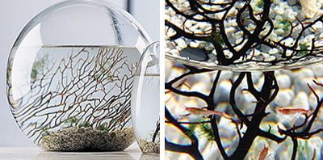  NASA scientists invented the EcoSphere – inside a sealed glass container, there are air, water, gravel, and three living things – algae, shrimp, and bacteria. Usually, these three living things can stay alive in the container for two or three years until the shrimp become too old to live. The picture above shows an EcoSphere and its inside parts. The EcoSphere is a closed ecosystem and has no exchange of matter with the outside environment. | 

